
2014 WiT AWARDS – NOMINATIONS NOW OPEN
MEDIA RELEASE, 30 May 2014

Women in Technology have announced this week the opening of nominations for the 17th Annual WiT Awards.
The WiT Awards recognise and reward women working in the technology fields, both in ICT and Life Sciences.
Winners receive recognition as innovative industry leaders irrespective of age or seniority and gain exposure to individuals, clients, experts and businesses engaged in ICT and biotechnology locally and globally.
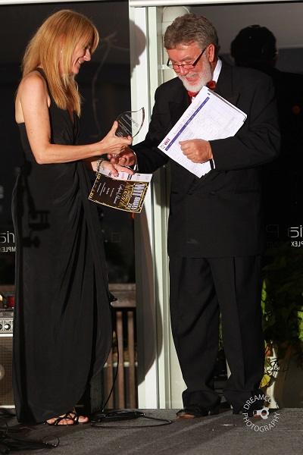Networking and mentoring opportunities exist for the winners with our high profile sponsors such as QUT ihbi, Griffith, Datacom and Hewlett Packard.
Professor Selena Bartlett, Group Leader in Addiction Neuroscience & Obesity at the Translational Research Institute & the Cells & Tissues Domain at IHBI and now WiT Life Sciences Ambassador, knows first hand the benefits of taking part in the WiT Awards. “When I was nominated I initially thought that there had been a mistake. I like so many other women in technology fields, did not have the same appreciation of myself as other’s had of me and in fact I was a little embarrassed by the attention.” “Since taking a leap of faith, apply and eventually win two awards, my career has been on a rapid uphill climb. The people I have met and journey that those relationships have taken me on has been extraordinary. I have also been able to explore other technology platforms to broaden the reach of my research, which I ordinarily would never have been exposed to.” said Selena. “The whole process has been well over and above anything I could have anticipated.”
Nominations can be made by downloading the Nominations Form from the Women in Technology website www.wit.org.au.
Further information:
Lisa Cawthorne – WiT Operations Manager, 0430 219 091, secretariat@wit.org.au

